Ryan Richter, Ryan Moore

Group 11

CS2028

Lab 2

Lab 2 Report

Task 1

The concepts of file I/O and class manipulation are very important concepts now and going forward in CS. For an example, an employer could have you read data from a spreadsheet and have you use it in a certain way. Classes are a foundational tool in C++ and a helpful way to manage data. Classes will be especially helpful in the future of this course, as they are very flexible and useful.

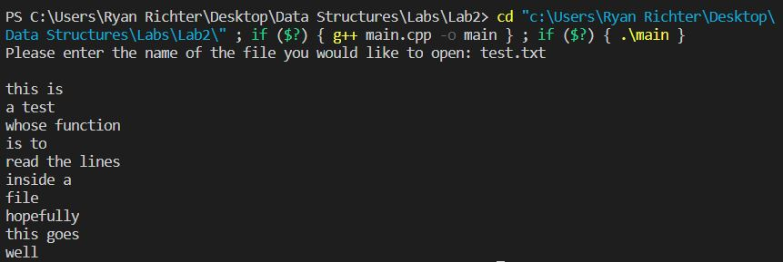

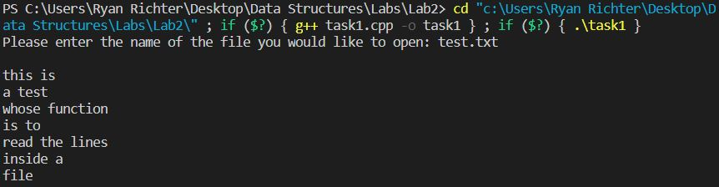

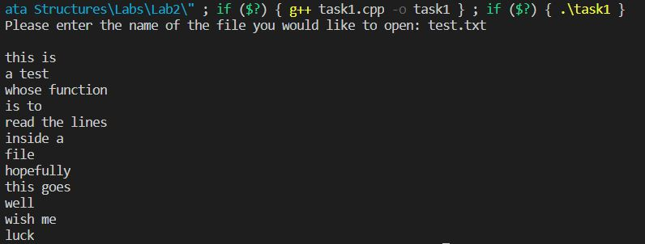

Since this task’s purpose was only to read data from the file, the file access flag “ifstream” was used.

Task 2

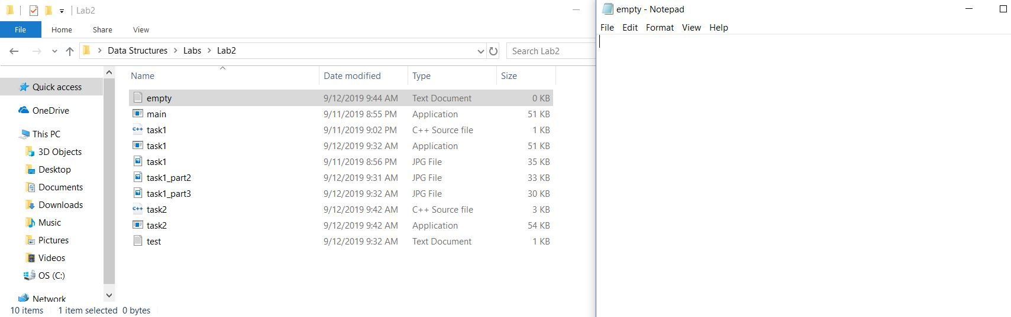

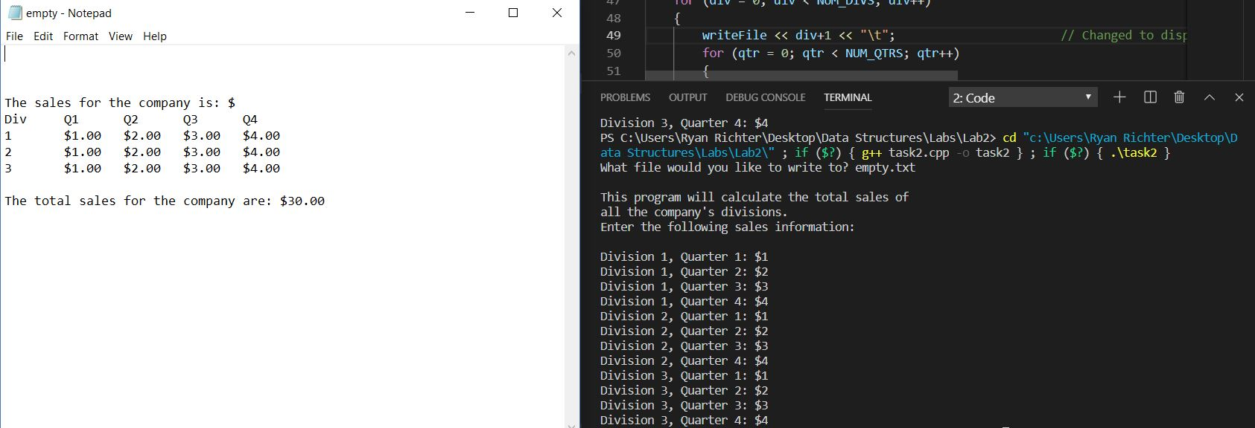

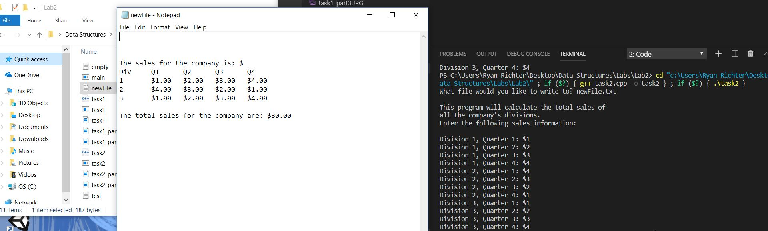

Since this task’s only purpose was to write to a file using data from the terminal, the file access flag “ofstream” was used.

In testing the three tasks, we learned that the best approach was to look at the test cases before beginning to code the program. It is easier to code the program with the test cases in mind. Of course, if there are changes that need to be made if the tests fail, they can be considered after the program is done being written.